

|  |
| --- |
|  |
|  |
| FYP SRS |
| **Authors**  *Laraib Sajjad (FA17-BSE-071)*  *Misbah ()*  **Affiliation**  *COMSATS University Islamabad, Wah Campus*  1-Jan-2021 |

|  |  |
| --- | --- |
|  |  |
|  |
| Contents  1.Introduction 4  1.1 Purpose of this document 4  1.2 Scope of this document 4  1.3 Overview 4  1.4 Business Context 4  2. General Description 4  2.1 Product Functions 4  2.2 Similar System Information 5  2.3 User Characteristics 5  2.4 User Problem Statement 5  2.5 User Objectives 5  2.6 General Constraints 5  3. Functional Requirements 6  4. Interface Requirements 7  4.1 User Interfaces 7  4.2 Hardware Interfaces 7  4.3 Software Interfaces 7  5. Performance Requirements 8  6. Design Constraints 8  6.1 Standards Compliance 8  6.2 Aesthetics 8  7. Other non-functional attributes 9  8. Operational Scenarios 11  8.1 Usecase Diagram 11  8.2 class Diagram 12  8.3 Activity Diagram 13  8.4 Sequence Diagram 14  9. Preliminary Schedule 23  10. Preliminary Budget 23  11. Appendices 23  11.1 References 23 |

## 1.Introduction

This section will discuss the purpose, scope, overview and business context of this project.

### 1.1 Purpose of this document

The intended audience are Developers, Database Administrators, and Researcher

### 1.2 Scope of this document

The document will provide detailed user requirements. The specification of the requirements will give the direction of the project. The infrastructure of the project will be based on the document. The developing team will be clear that what they have to develop and how. The user could match the project with its requirements using the document.

### 1.3 Overview

This is Desktop online game called **“Shooting Monsters”**. Basically, this will work online. All players will must be connected with internet to join game. All players will fight with each other. The Player who has highest death rate will lose. Any player whose power gone to zero will be respawned. Match is dynamic (When all players left game) game will end. There are multiple players can fight with each other using guns

### 1.4 Business Context

this project aims to develop a gaming application according to the need of end users so, they can enjoy their free time. The project focus on new technology so, the market demand will be good.

## 2. General Description

### 2.1 Product Functions

This is Desktop online game called **“Shooting Monsters”**. Basically, this will work online. All players will must be connected with internet to join game. All players will fight with each other. The Player who has highest death rate will lose. Any player whose power gone to zero will be respawned. Match is dynamic (When all players left game) game will end. There are multiple players can fight with each other using guns

While playing game any player can select from two given modes which he wants to play as Online and Offline mode as name of Online shows it can only be play able having the working internet connection to connect with cloud and can only connected to other players using internet. So, when player wants to play online mode, he must have to create the server for other players to join and can play in multi-player mode across globe. While one player created server other players just have to join that created server just by clicking its name given on Create Server screen. After joining of the server player have to select from given categories as SWAT and Assault. Any player whose power gone zero will be respawned. HP (Health points), Scores, Death and will be shown on top right of screen. Player can control movement of character. Health Score also displayed on enemy head. Player can use multiple guns.

### 2.2 Similar System Information

This product is standalone but can be used by other products as a plugin. Describes the relationship of this product with any other products. Specifies if this product is intended to be stand-alone, or else used as a component of a larger product. If the latter, this section discusses the relationship of this product to the larger product.

### 2.3 User Characteristics

Users with the basic knowledge of desktop application, can use this system, no deep knowledge about software systems is required to use this system. The user should know how to give input to the interface. Our primary consumers are end users or people from marketing department.

### 2.4 User Problem Statement

The problem that most of the user’s face is how to use a product? because of unfriendly visual design and another problem is complex language used in products which makes understanding of system very difficult.

2.5 User Objectives  
The user wants the product which is easy to understand and easy to use. Simple language is used and user friendly ui.

### 2.6 General Constraints

The designer should design a system that is eye catching. The system should be responsive and proud user great experience.

## Functional Requirements

This section lists the functional requirements in ranked order from more important to least important.

|  |  |  |  |
| --- | --- | --- | --- |
| **S. No.** | **Functional Requirement** | **Type** | **Status** |
| 1 | The player should be able to start a game | Core |  |
| 2 | The player should be able to create the server | Core |  |
| 3 | Players should be able to join the server. | Core |  |
| 4 | The player should be able to aim while the character is holding a weapon | Core |  |
| 5 | The player should be able to fire the gun his character is holding gun. | Core |  |
| 6 | The player should be able to jump. | Core |  |
| 7 | The player should be able to move right. | Core |  |
| 8 | The player should be able to move left. | Core |  |
| 9 | The player should be able to backward and forward. | Core |  |
| 10 | The player should be able to control the movements of his character and move it freely in the map | Core |  |
| 11 | The player should be able to go into houses. | Core |  |
| 12 | The player should be able to damage opponent’s health | Core |  |
| 13 | The player should be able to leave the server. | Core |  |
| 14 | The player should be able to view the score, death and ammo. | Nominal |  |
| 15 | The player should be able to exit the game. | Core |  |
| 16 | The player should be able to enter the character name | Nominal |  |
| 17 | The player should be able to interact with the environment (like containers, roads, tunnels and houses.) | Core |  |
| 18 | The player should be able to attack with gun to other players. | Core |  |
| 19 | The player should be able to select AI mode from options. | Core |  |
| 20 | The player should be able to send massage to other players. | Core |  |

1. **Application Interface**
   1. **Description**  
      this interface will be provided to the end user so they can play the game
   2. **Criticality**  
      Medium
   3. **Technical issues**  
      server dependency
   4. **Cost and schedule**
      1. Server cost
   5. **Risks**
      1. Security Vulnerability

**Dependencies with other requirements**  
Highly dependent on server module

.

## Interface Requirements

In this section we have discussed the interface requirements

4.1 User Interfaces  
Describes how this product interfaces with the user.

* + **4.1.1 GUI**  
    Describes the graphical user interface if present. This section should include a set of screen dumps or mockups to illustrate user interface features. If the system is menu-driven, a description of all menus and their components should be provided.
  + **4.1.2 Diagnostics or ROM**  
    Debugging information and diagnostic data will be stored in a log file only accessible by the developer

4.2 Hardware Interfaces  
There are no hardware interfaces

### 4.3 Software Interfaces

* + User interface
  + Server interface
  + Admin interface

## 5. Performance Requirements

Unity 3d framework, which will make our product much more optimized because it is small and minified use much more recursive syntax. Materialize CSS front end should be use because it provides amazing UX and UI. The main important reason to use it is that it is based on Google Material Design which suggests Ease of Access for user. C# will be used for fast data processing.

## 6. Design Constraints

Specifies any constraints for the design team using this document.

### 6.1 Standards Compliance

Coloring Scheme should be user friendly

Material Design Should be followed

### 6.2 Aesthetics

Display the game logo in the landing page

The background should be transparent

## 7. Other non-functional attributes

Specifies any other particular non-functional attributes required by the system. Examples are provided below.

|  |  |  |
| --- | --- | --- |
| **S. No.** | **Non Functional Requirements** | **Category** |
| 1 | There will be multiple types of guns:   * Cz805 * damage : 5 * Ammo. : 40 * clip count : 1000 * range : 100 | System Level |
|  | * Sniper SVD * damage : 80 * range : 2500 * clip count: 1000 * Ammo:5 * MP05 * damage : 40 * range : 100 * clip count: 1000 * Ammo:40 * range 100 |  |
| 2 | Guns will have 1000 Clip and 1 clip have 40 or 5 bullets and require reloading after zero remaining bullet in clip | System Level |
| 3 | The player will be able to move in complete 360 degree | User Level |
| 4 | The main objective of player should be to lowest death rate. | User level. |
| 5 | The player name entered by the user will be used on character head between the games. | User Level |
| 6 | When player got shot its main screen (face view) will become bloody. | User Level |
| 7 | The timer and kill count will always be visible to the user in UI. | User Level |
| 8 | The player will be shown the number of bullets in the gun available in magazine for the gun | User Level |
| 9 | When the gun held by the player goes empty it will reloaded manually by pressing R. | User Level |
| 10 | The player will die when they completely lost 100% their health. | User Level |
| 11 | The player name can be as long as 16 characters maximum and can be as minimum as 1 character | System Level |
| 12 | While playing in the AI mode there will be bots (Computer made fake players) that will shoot at players. | System Level |

## 8. Operational Scenarios

### 8.1 Usecase Diagram

## 

### 8.2 class Diagram

8.3 Activity Diagram 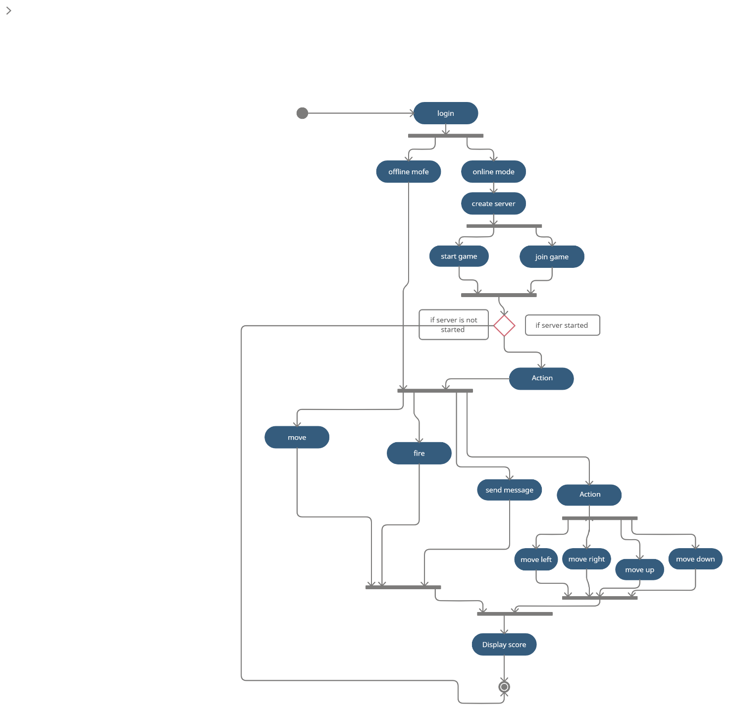

### 8.4 Sequence Diagram

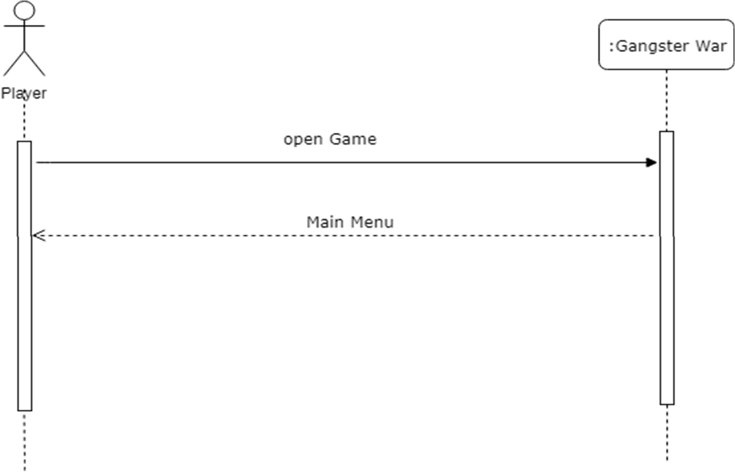

**Figure 2-2: SSD (Open Game)**

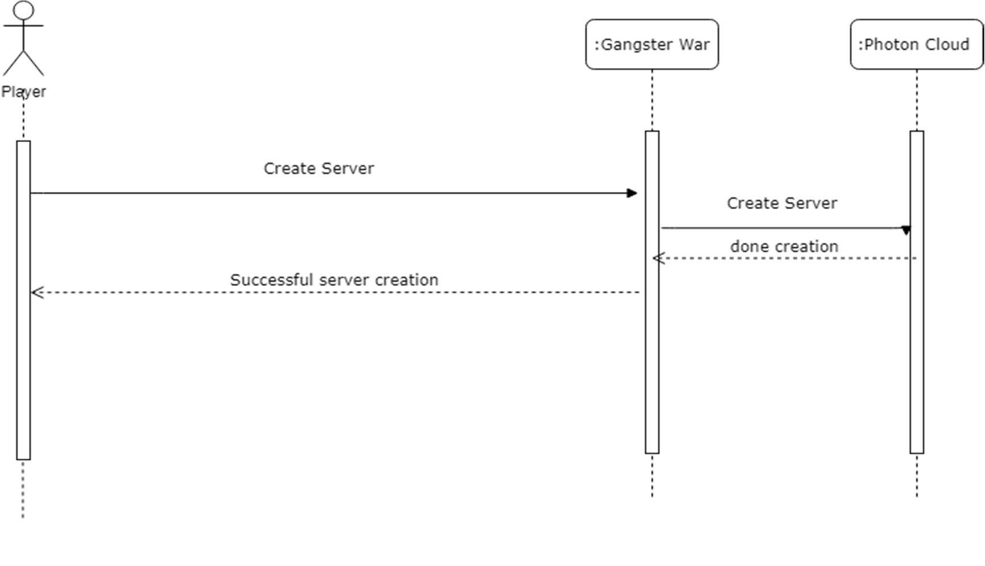

**Figure 2-3: SSD (Create Server)**

33

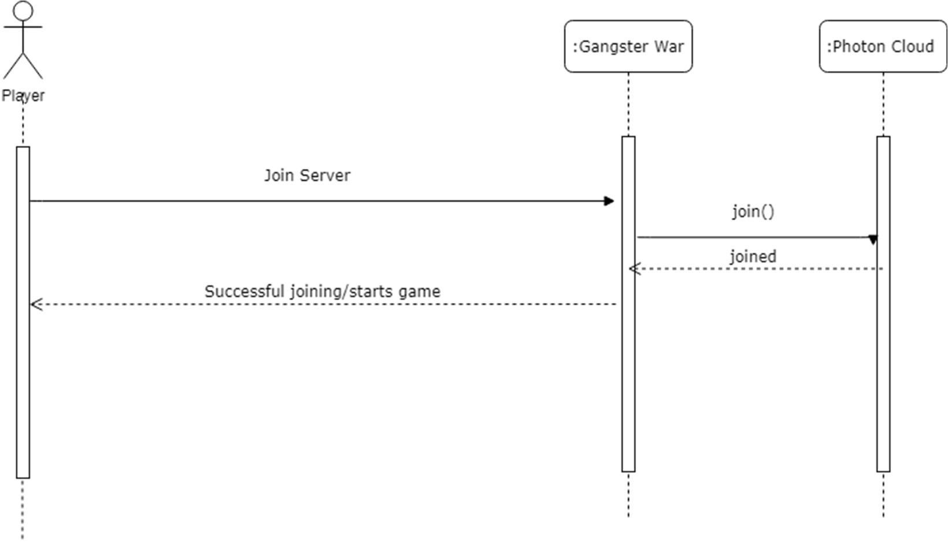

**Figure 2-4: SSD (Join Server)**

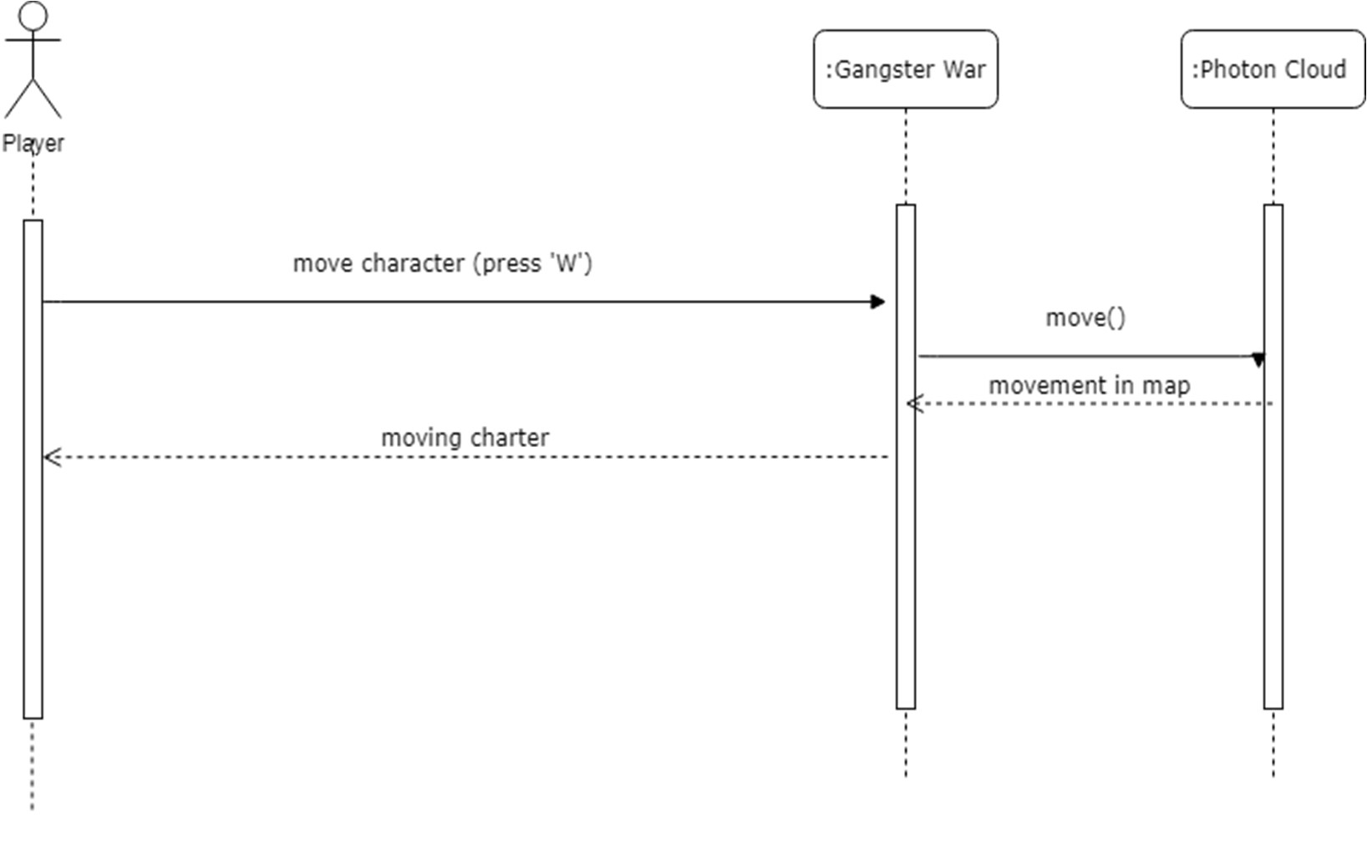

**Figure 2-5: SSD (Moving Character forward)**

34

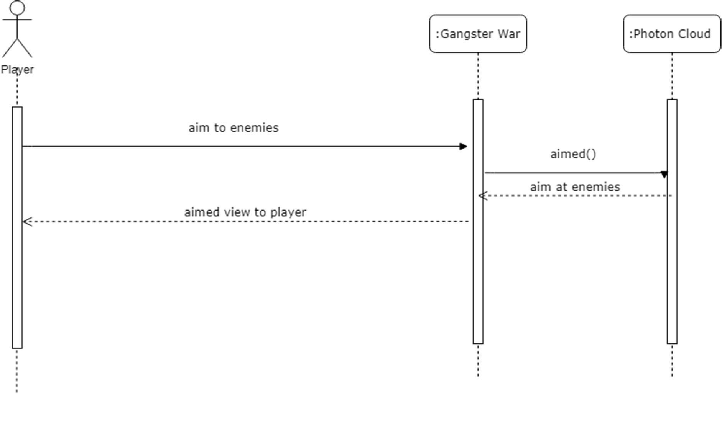

**Figure 2-6: SSD (Aiming At Enemies)**

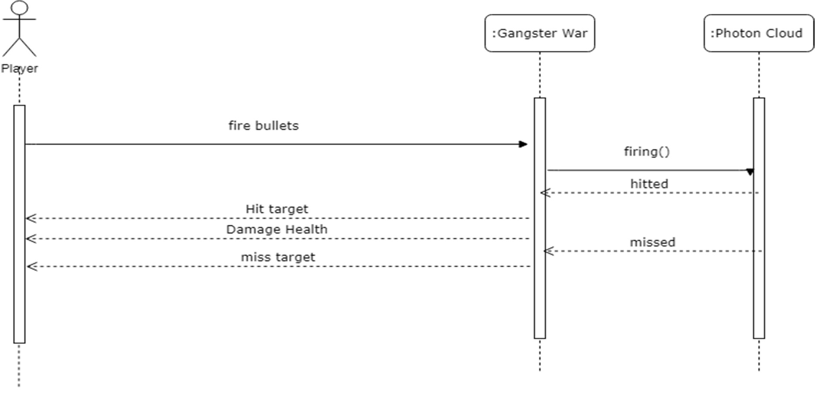

**Figure 2-7: SSD (Firing At Enemies)**

35

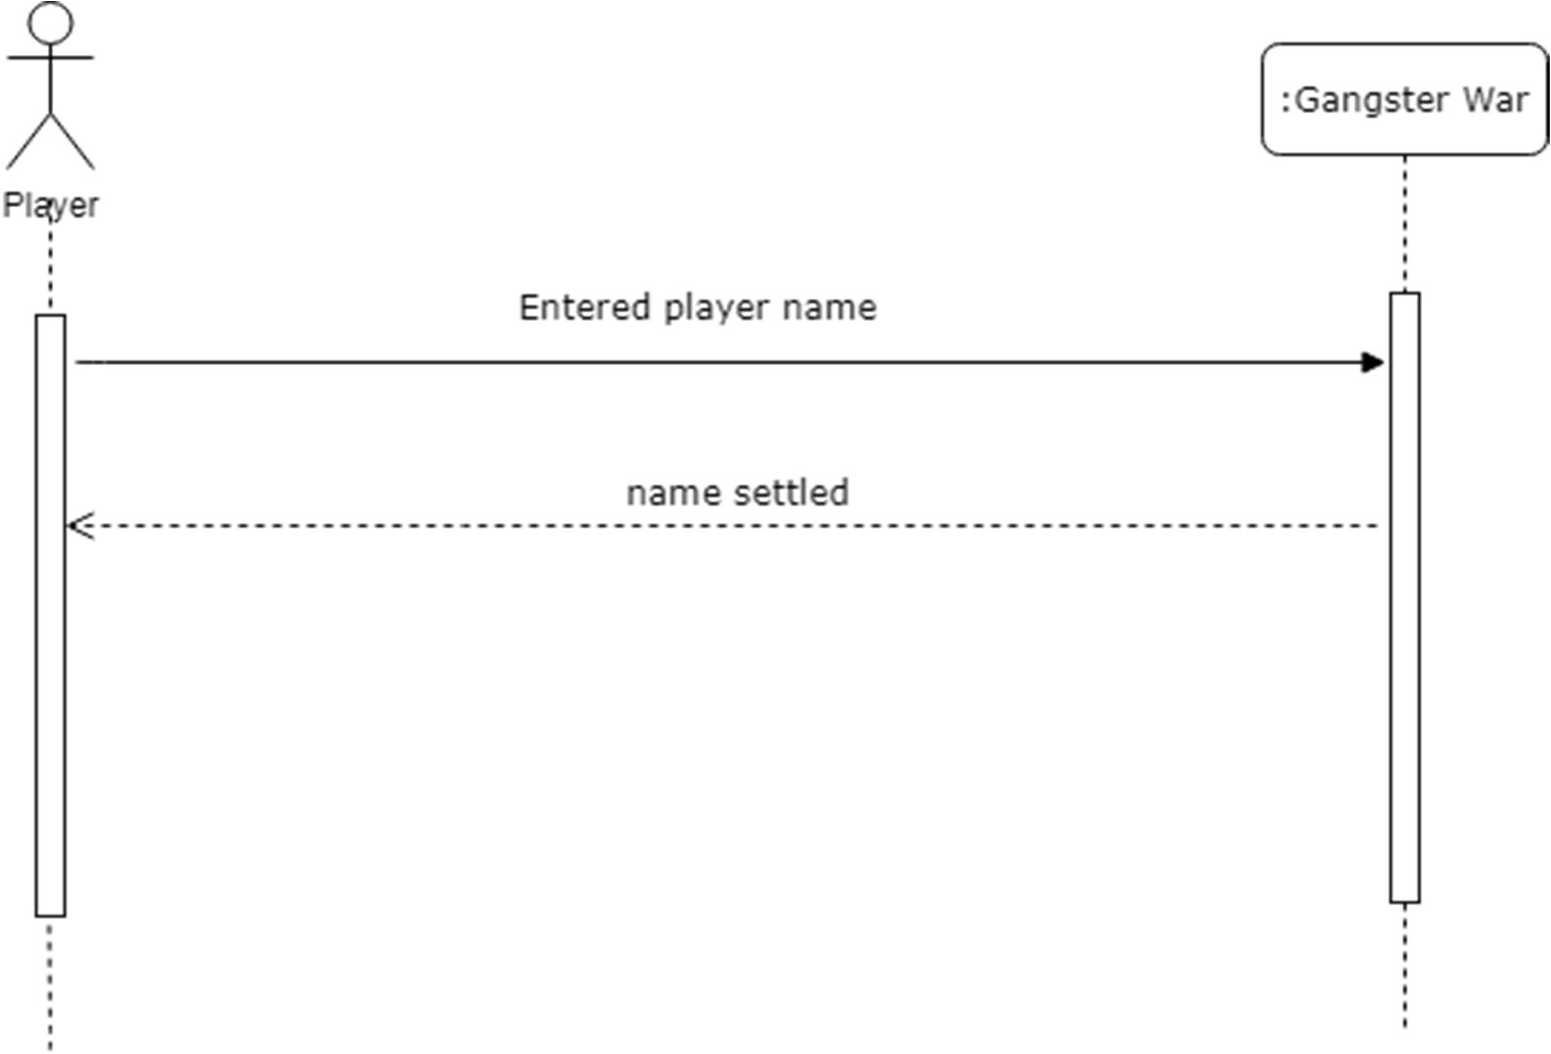

**Figure 2-8: SSD (Enter Player Name)**

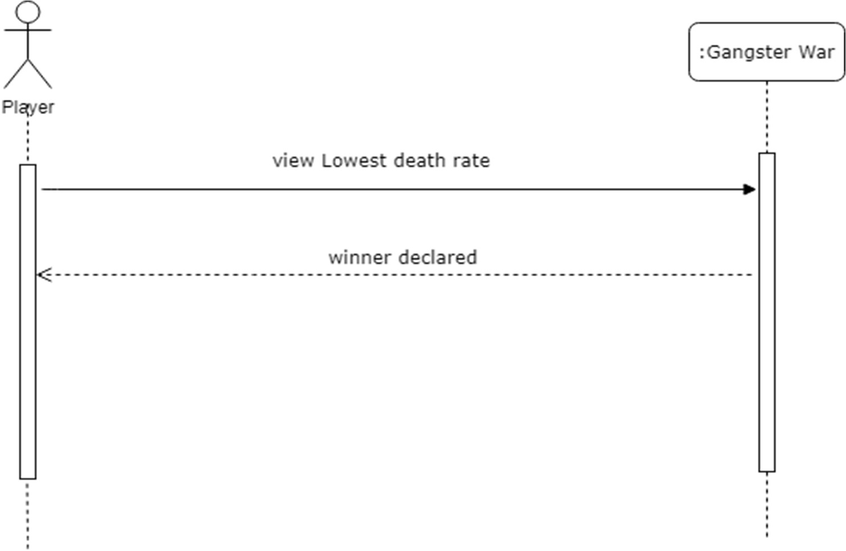

**Figure 2-9: SSD (View Lowest death)**

36

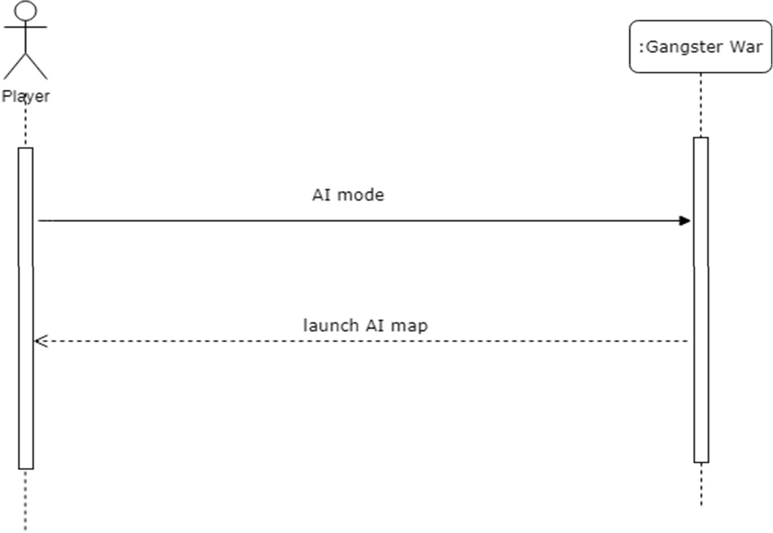

**Figure 2-10: SSD (AI Mode)**

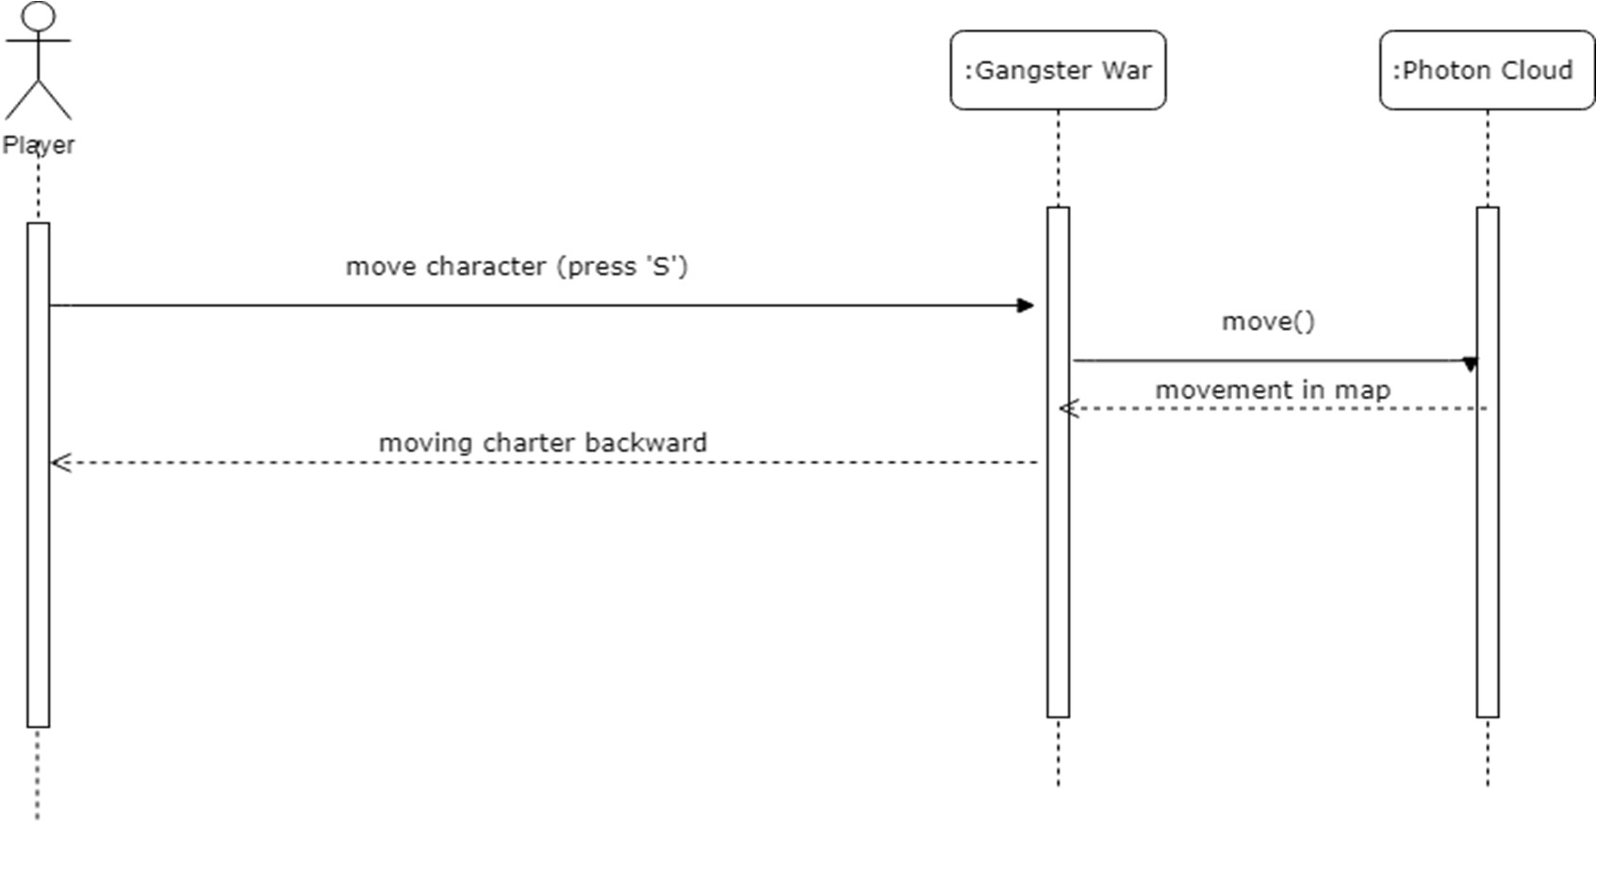

**Figure 2-11: SSD (Move Backward)**

37

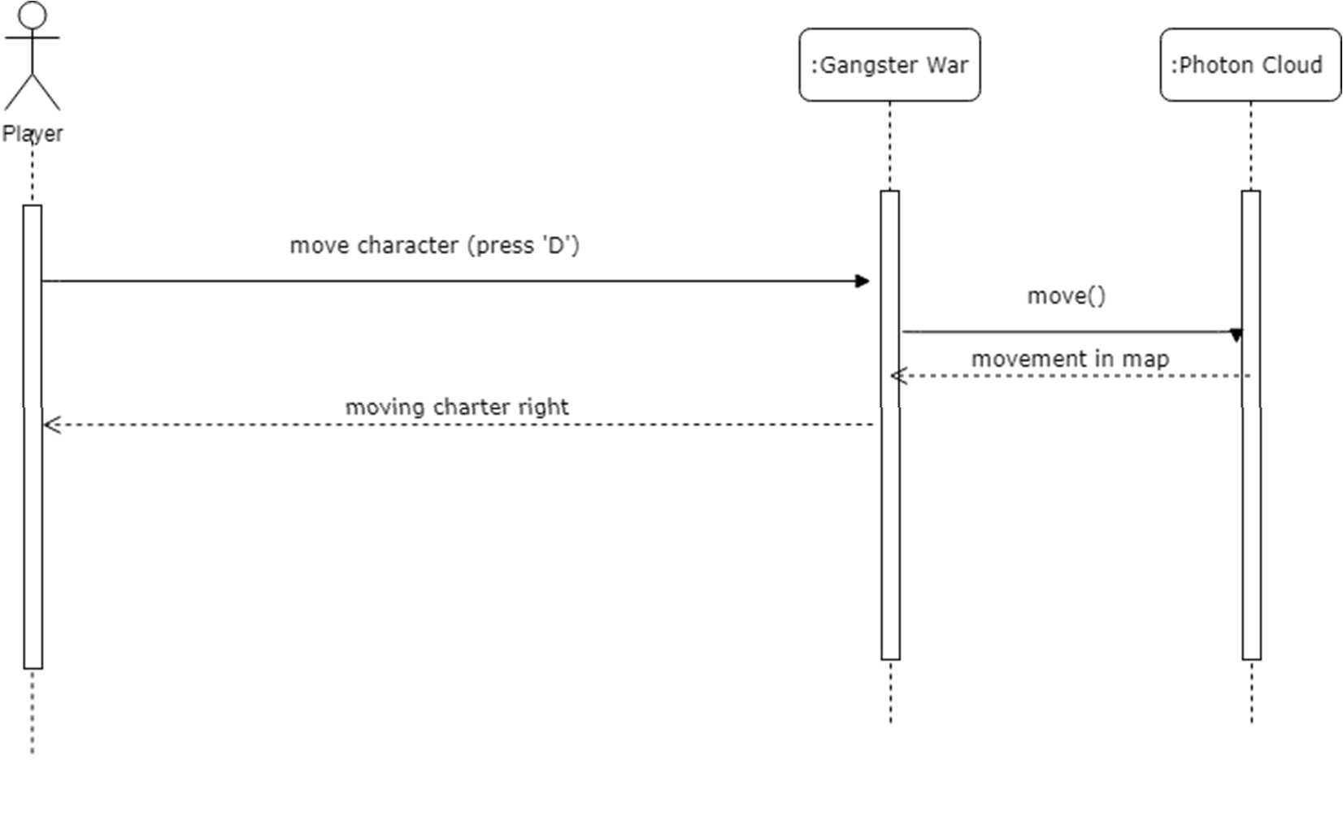

**Figure 2-12: SSD (Move Right)**

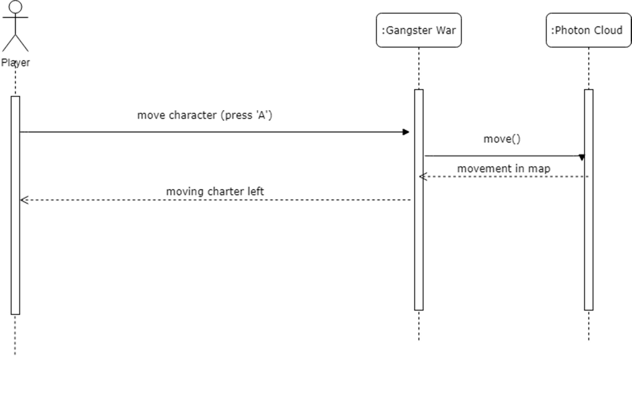

**Figure 2-13: SSD (Move Left)**

38

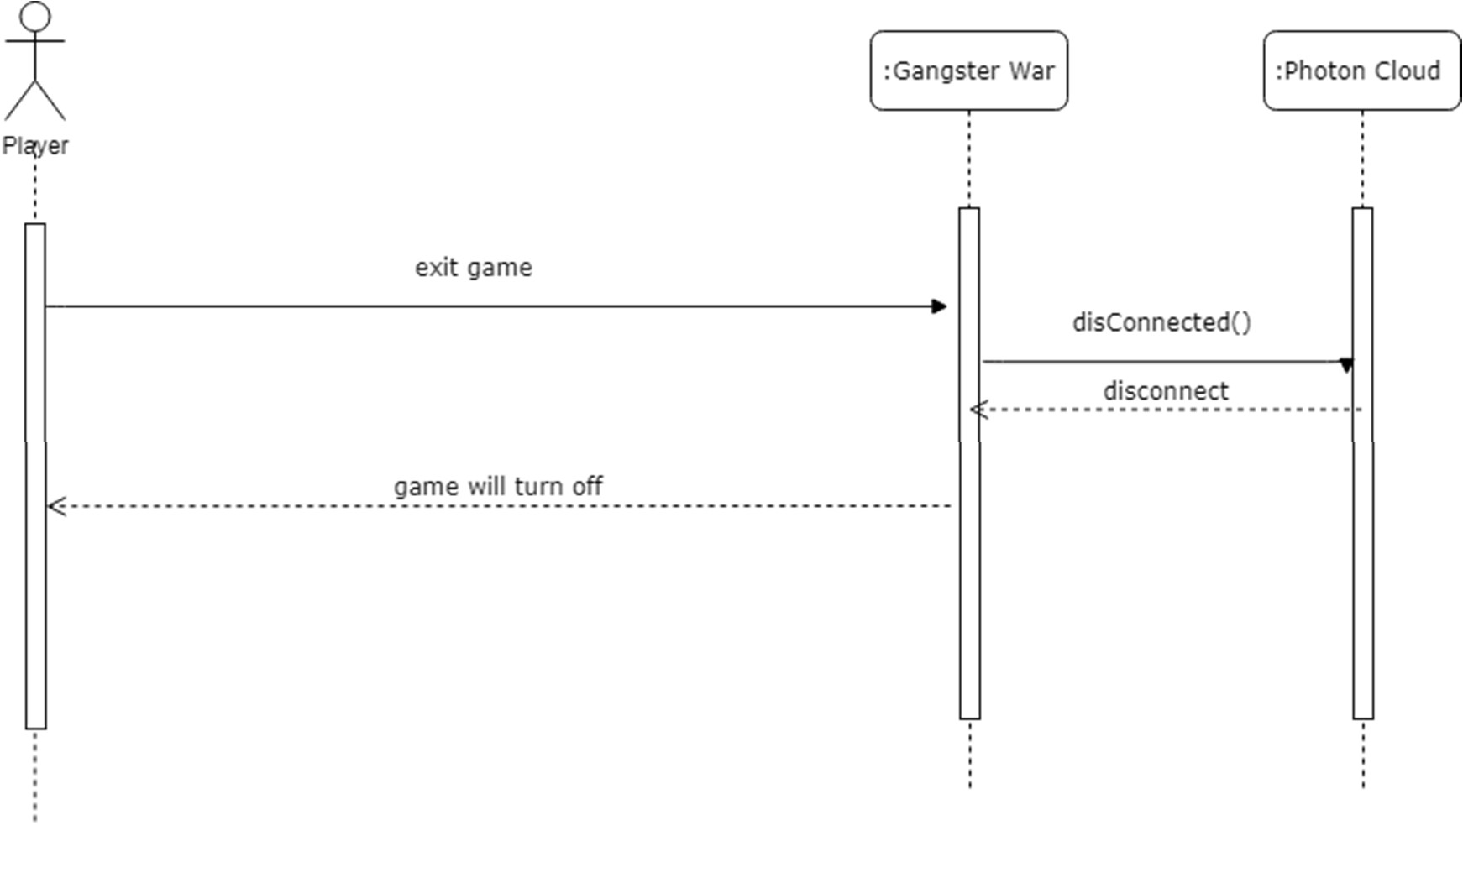

**Figure 2-14: SSD (Exit Game)**

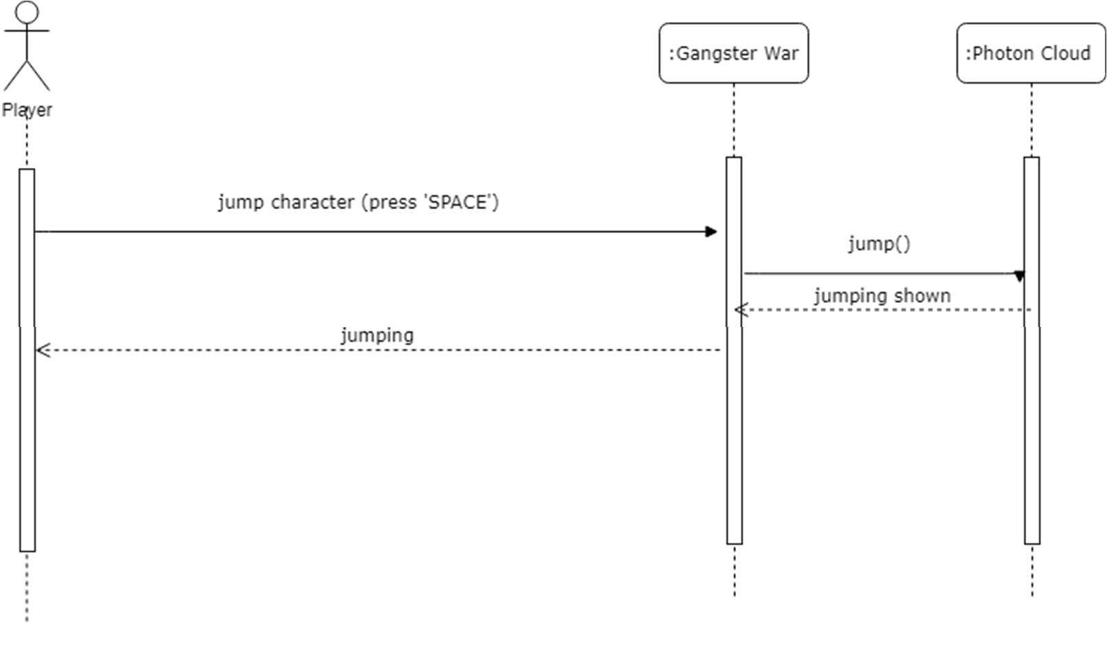

**Figure 2-15: SSD (Jumping)**

39

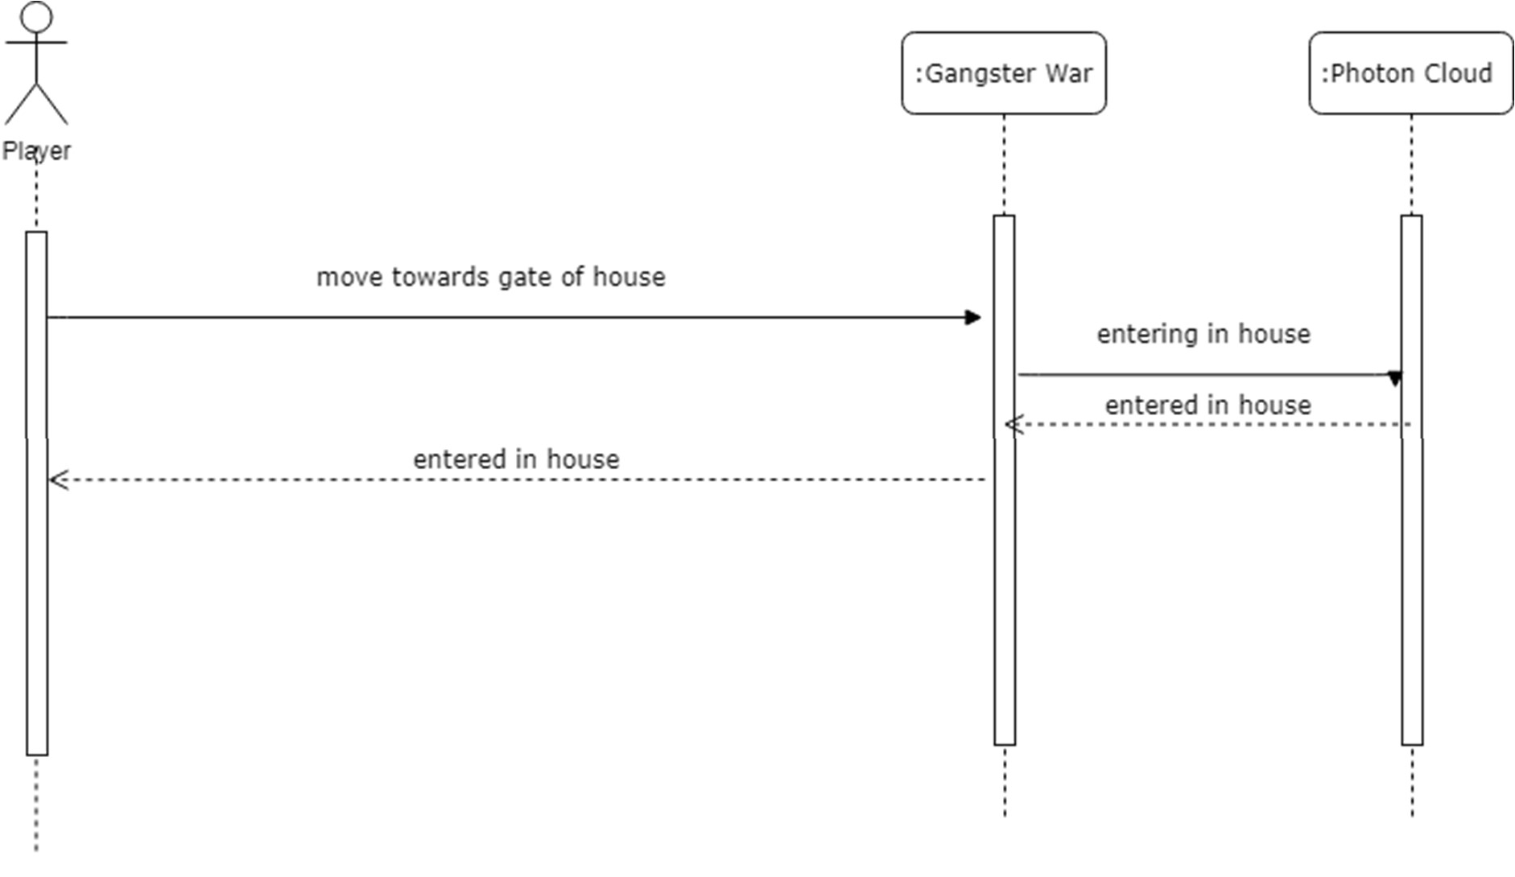

**Figure 2-16: SSD (Enter In House)**

.

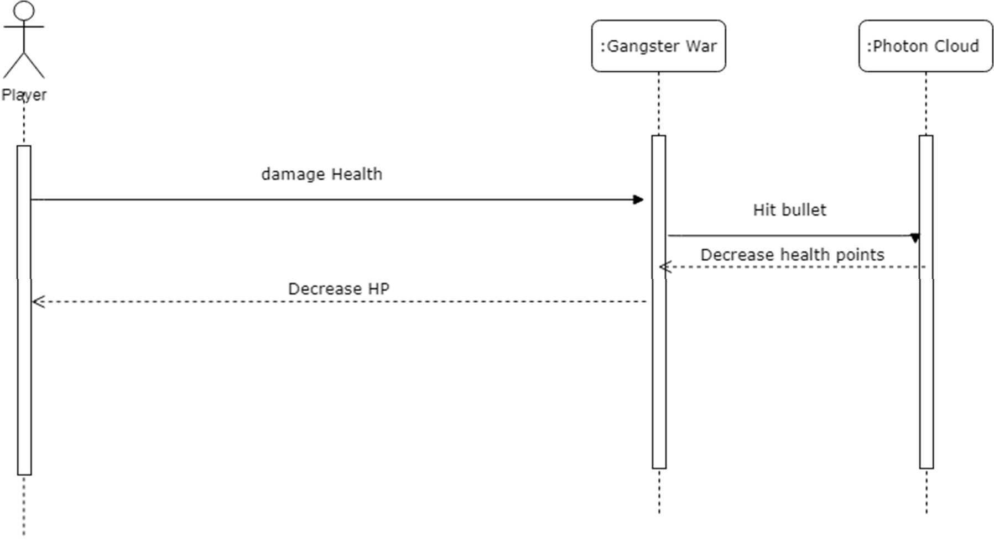

**Figure 2-17 SSD (Damage Health)**

40

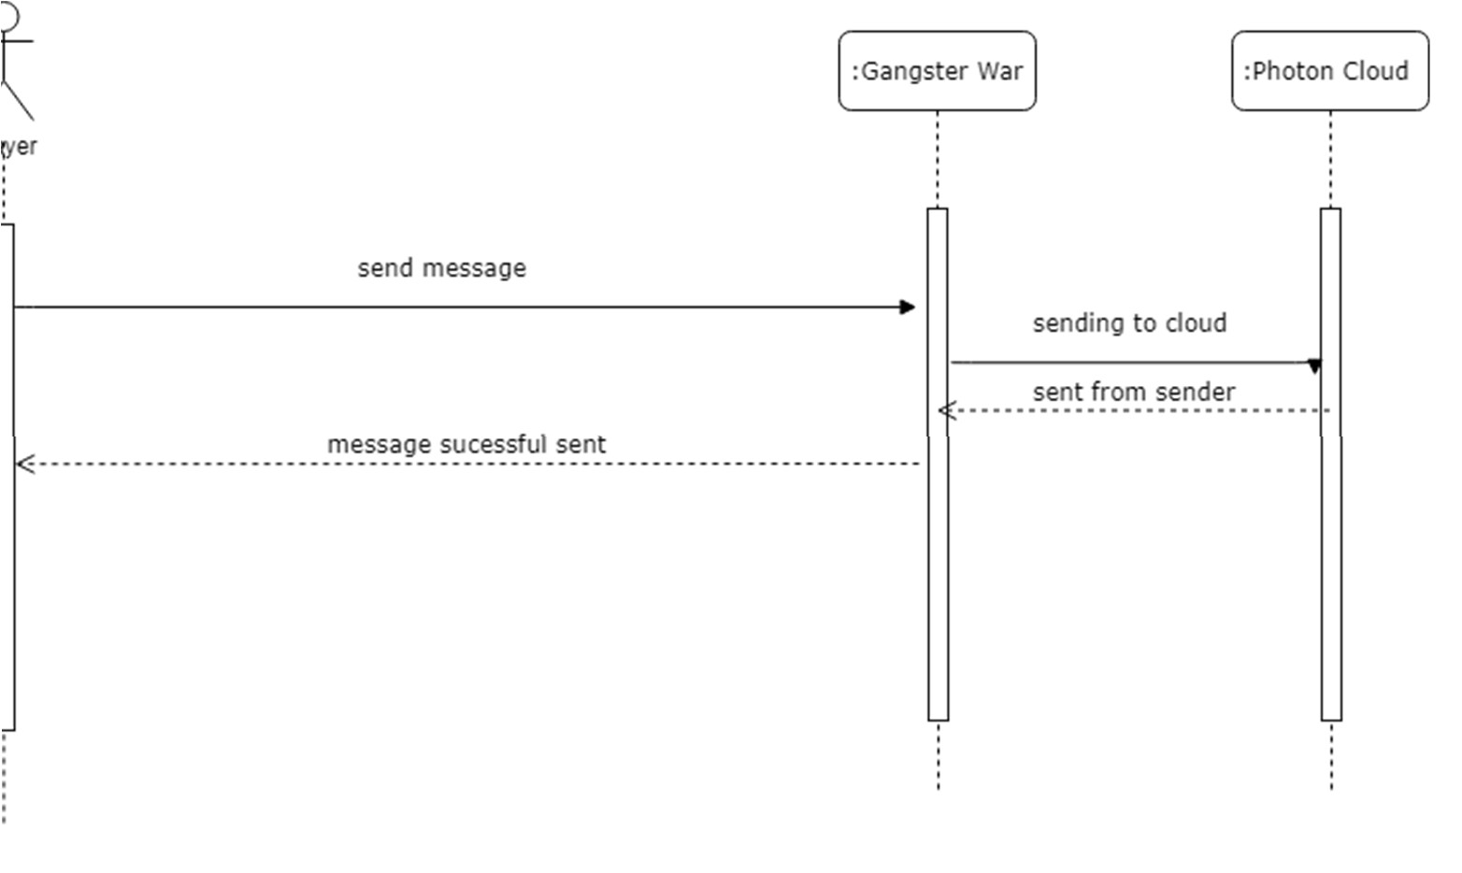

**Figure 2-18 SSD (Sending Message)**

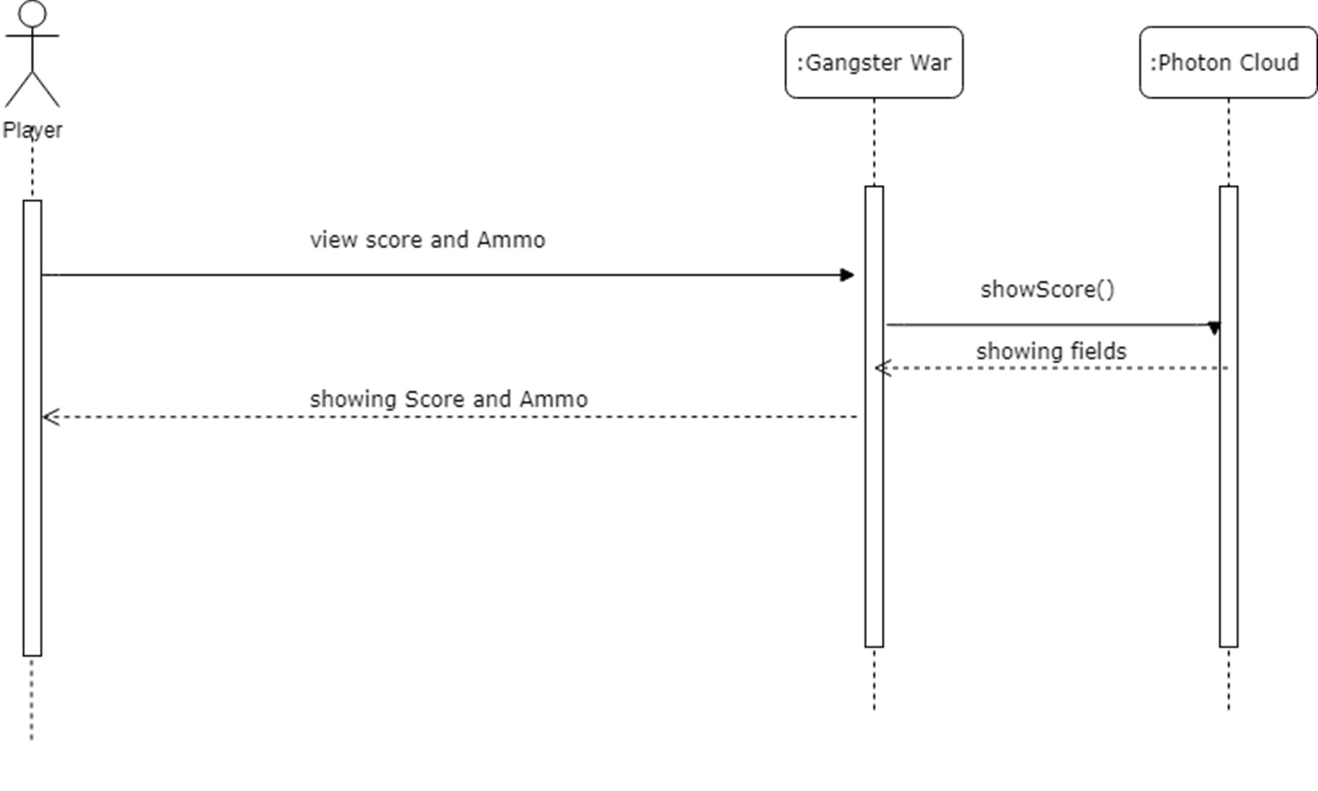

**Figure 2-19 SSD (Viewing Score and Ammo)**

## 9. Preliminary Schedule

The first module of project will be completed in 4 – 5 weeks. The next two modules will be completed in 5-7 weeks and the rest of project will be completed in 3-4 weeks

## 10. Preliminary Budget

|  |  |
| --- | --- |
| Total cost | 1500 – 20000 Rs. |

## 11. Appendices

Below are the references of existing systems to our project

### 11.1 References